**Introduction**

A great man wants to build a Bar in Toronto and is searching a good place. I should help him to choose the better place.

**Business Problem**

This man have some interest to build a new Bar. He want to put his Bar near:

* Stadium
* 2-Universities
* 3- Offices

He customer thinks these three locations guarantee a lot of people who want to go to a bar. We are going to use Foursquare information for recollect this information

**Data**

We are using <https://en.wikipedia.org/wiki/List_of_postal_codes_of_Canada:_M> for the postal Canada in general and Neighbors and cities.

<http://cocl.us/Geospatial_data> For the Latitude and Longitude of Canada

The categories that we chose are

Stadium: 4bf58dd8d48988d184941735Universities: 4bf58dd8d48988d198941735

Offices: 4bf58dd8d48988d124941735

https://developer.foursquare.com/docs/resources/categories

**Methodology**

We use beautiful Soup library to scrape an article on Wikipedia with the Toronto´s neighborhood. We ordered the table and then import the geo data. That help us to create a map with the Toronto´s neighborhood. We have special attention with theses neighborhood because the client asked us for help him. After that we use foursquare for the interest of the client about the Universities, Stadiums and Offices. Obviously, we add to the list the “Bars”.

We define weights for each category, depending the taste of the client.

Universities = 3

Office = 3

Stadium = 1

We calculated the score of all of these categories and compare with the Bar and the better neighbor. The highest score determine the best place to put the Bar.

**Result**

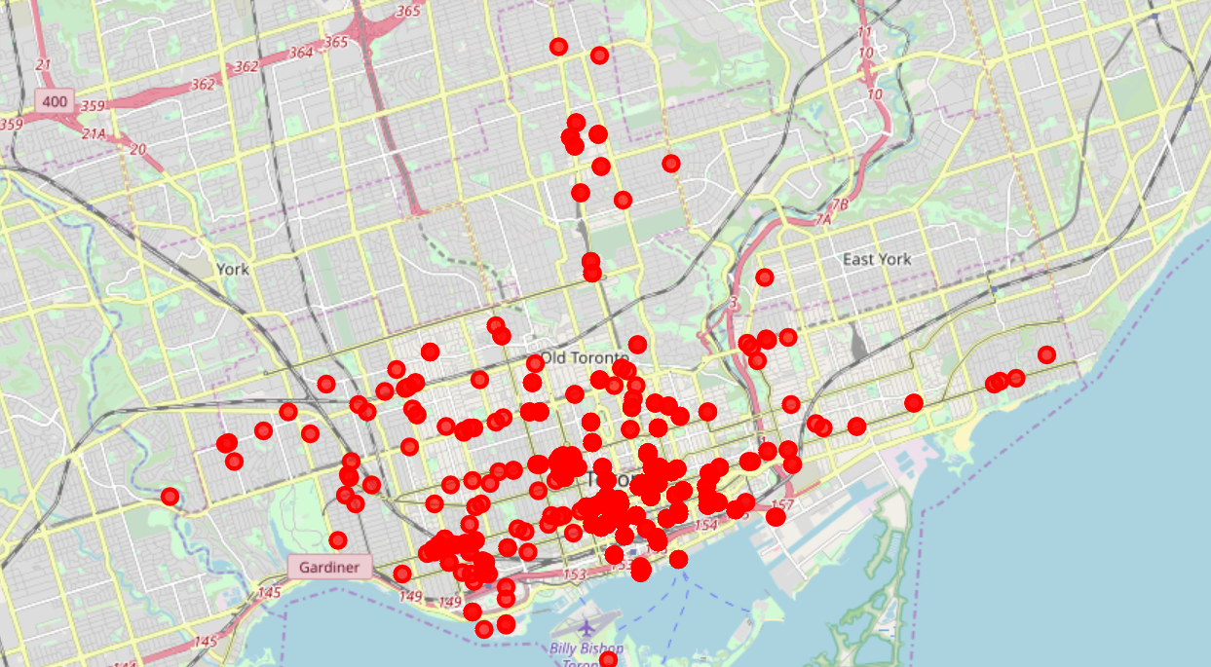

648 bars in Toronto (Red points)

*755 universities in Toronto (Green)*

*207 Stadium in Toronto (Yellow)*

*1622 office in Toronto*

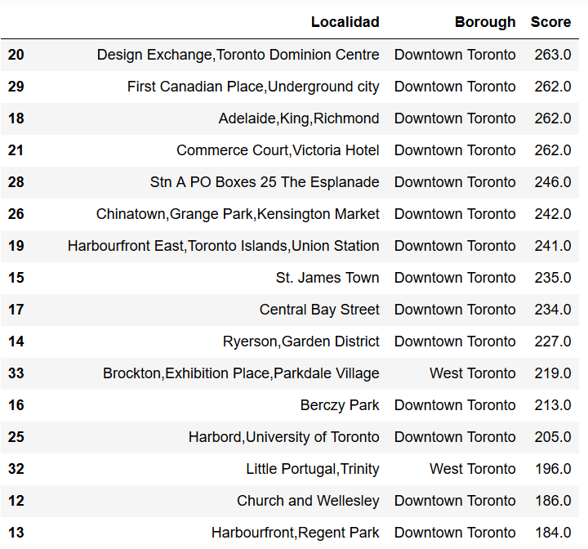

*The final Score with Centre as winner*

* Red = Another Bars
* Green= Stadium
* Fuchsia = Office
* Yellow = Universities
* Blue = Neighbor

**RESULT**

As result we can said the general Toronto neighbor are very competitive but we could see some spaces between Queen and King. This was an exhaustive analysis so we put on the map ALL the bars with out specification so we could do a next step of our analysis putting some exception of “specific bars”. Also as conclusion we see a good position in the neighbor surrounded of office so is a good idea to open a Bar there.